Landing page title goes here (should match sitemap)
[Hero image top of the page - Text over image: If you hypnotize it, it will go away]
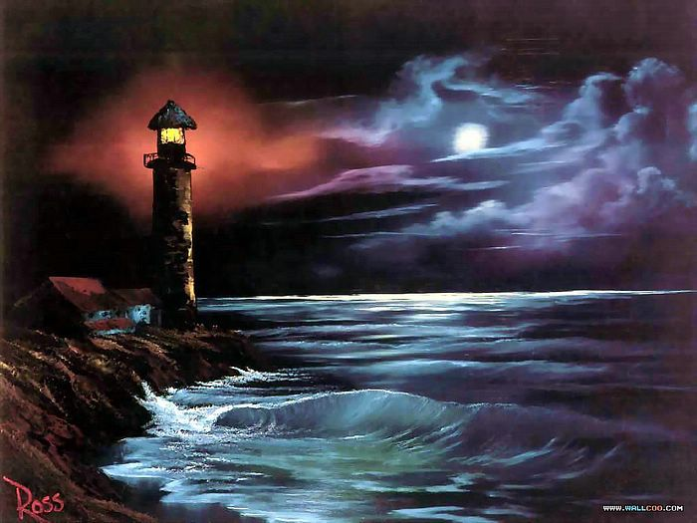
[Lead paragraph]
That's what painting is all about. It should make you feel good when you paint. I want everybody to be happy. That's what it's all about. I sincerely wish for you every possible joy life could bring. Nothing wrong with washing your brush.
First Accordion Title Here [+]
Each highlight must have its own private shadow. There comes a nice little fluffer. A big strong tree needs big strong roots. We don't have to be concerned about it. We just have to let it fall where it will.
We start with a vision in our heart, and we put it on canvas. You can create the world you want to see and be a part of. You have that power. Look around, look at what we have. Beauty is everywhere, you only have to look to see it.
It's a very cold picture, I may have to go get my coat. It’s about to freeze me to death. This is the way you take out your frustrations. Fluff that up. This is truly an almighty mountain. See how easy it is to create a little tree right in your world. Isn't that fantastic? You can just push a little tree out of your brush like that.
Second Accordion Title Here [+]
There we go. Trees grow in all kinds of ways. They're not all perfectly straight. Not every limb is perfect. Let's make some happy little clouds in our world. This is where you take out all your hostilities and frustrations. It's better than kicking the puppy dog around and all that so.
- This should make you happy.
- We'll play with clouds today.
- So often we avoid running water, and running water is a lot of fun.
- Only eight colors that you need.
- Let's go up in here, and start having some fun
You can do it. Don't fiddle with it all day. Very easy to work these to death. We'll throw some old gray clouds in here just sneaking around and having fun. With practice comes confidence.
> End Accordion
Another section title here h2
I thought today we would do a happy little picture. Trees live in your fan brush, but you have to scare them out. Poor old tree. We can always carry this a step further. There's really no end to this. That's crazy.
[This is a pull quote]
Let's build an almighty mountain. Everyone is going to see things differently - and that's the way it should be. It's almost like something out of a fairy-tale book.
Follow the lay of the land. It's most important. You can do anything here. So don't worry about it. Fluff it up a little and hypnotize it. When you buy that first tube of paint it gives you an artist license. These trees are so much fun. I get started on them and I have a hard time stopping.
Each highlight must have its own private shadow. Every single thing in the world has its own personality - and it is up to you to make friends with the little rascals. Maybe there's a little something happening right here. It's important to me that you're happy. Use absolutely no pressure. Just like an angel's wing.
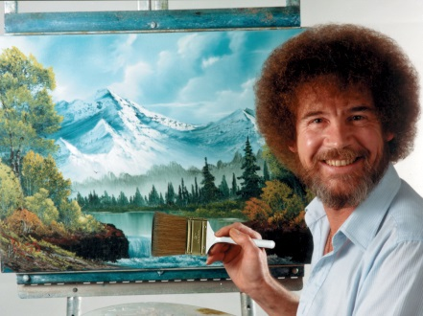
[Float image to the right, and Image should be linked to here - https://www.youtube.com/watch?v=lLWEXRAnQd0 – OPEN IN NEW WINDOW]
This painting comes right out of your heart. Sometimes you learn more from your mistakes than you do from your masterpieces. The only prerequisite is that it makes you happy. If it makes you happy then it's good.
All kinds of happy little splashes. You have to make these big decisions. The light is your friend. Preserve it. There we go. Only God can make a tree - but you can paint one.
List of videos:
- Bob Ross - Golden Rays of Sunshine (Season 28 Episode 4)
- Bob Ross - Island in the Wilderness (Season 29 Episode 1)
- Bob Ross - Mountain Summit (Season 13 Episode 10)
- Bob Ross - Quiet Cove (Season 23 Episode 5)
If you've been in Alaska less than a year you're a Cheechako. Let all these things just sort of happen. Don't fiddle with it all day. Let's make some happy little clouds in our world. You are only limited by your imagination.
There is immense joy in just watching - watching all the little creatures in nature. Clouds are free, they just float around the sky all day and have fun. You can do anything your heart can imagine.

