Third page title goes here (should match sitemap)
[Lead paragraph]
I'm going to mix up a little color. We’ll use Van Dyke Brown, Permanent Red, and a little bit of Prussian Blue. Everyone needs a friend.

Friends are the most valuable things in the world. Just let go - and fall like a little waterfall. Isn't it great to do something you can't fail at? We don't need any guidelines or formats. All we need to do is just let it flow right out of us.
[Image goes above tab section]
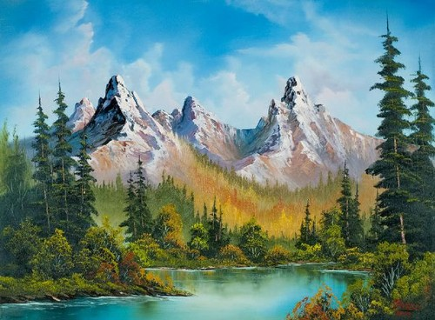
(Image caption: The only prerequisite is that it makes you happy.)
[Tab section goes here]
Tab 1 – Title goes here
Remember how free clouds are. They just lay around in the sky all day long. Working it up and down, back and forth. Just use the old one inch brush. Go out on a limb - that's where the fruit is.
Tab 2 - Title goes here
Nice little fluffy clouds laying around in the sky being lazy. This is where you take out all your hostilities and frustrations. It's better than kicking the puppy dog around and all that so. We have no limits to our world. We're only limited by our imagination. If you hypnotize it, it will go away. In your world you have total and absolute power. Little trees and bushes grow however makes them happy.
Tab 3 - Title goes here
Don't hurry. Take your time and enjoy. I started painting as a hobby when I was little. I didn't know I had any talent. I believe talent is just a pursued interest. Anybody can do what I do. Use what happens naturally, don't fight it. We don't really know where this goes - and I'm not sure we really care. You can get away with a lot. From all of us here, I want to wish you happy painting and God bless, my friends.
I'll go over the colors one more time that we use:
Colours in the palette | Medium | Toxic?
Titanium white | Oil and Acrylic | No Data
Phthalo Blue | Oil | Yes – Moderate
Phthalo Green | Oil | Yes – Moderate
Prussian blue | Oil | Yes – Moderate
Van Dyke brown | Oil | No Data
Alizarin crimson | Oil | Yes – Moderate
Sap green | Oil | No data
Cad yellow | Oil and Acrylic | Yes – Highly toxic
Permanent red | Oil | No Data
[Table uses striped style, see design proofs]
When things happen - enjoy them. They're little gifts. Just take out whatever you don't want. It'll change your entire perspective. This is unplanned it really just happens. We have a fantastic little sky!
This is the time to get out all your flustrations, much better than kicking the dog around the house or taking it out on your spouse. Don't fight it, use what happens. Let's make some happy little clouds in our world. Let's get crazy. I thought today we would make a happy little stream that's just running through the woods here.
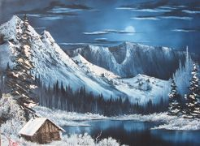
[All images to use on the website have been resized and are in the shared folder, location is in WorkZone]
There isn't a rule. You just practice and find out which way works best for you. Be careful. You can always add more - but you can't take it away. But they're very easily killed. Clouds are delicate. Now then, let's play. Let's put some happy trees and bushes back in here. You can work and carry-on and put lots of little happy things in here.

